
Lab 8: Matrix Art
CS 122L • 15 Points Total

Objectives
- Practice with Matrix operations
- Practice with Loops
- Practice file I/O (reading/writing) in MATLAB

Overview
Pictures made from characters are commonly found on the internet and in many applications. Things from detailed faces to simple shapes can be made with just computer characters. Some examples are shown below.
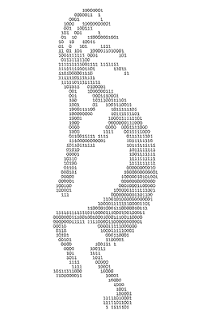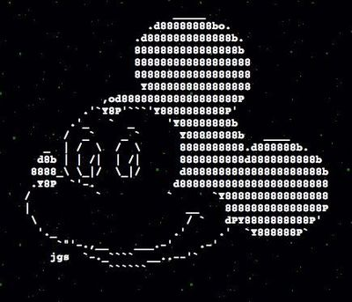
Figure 1: Computer Character Pictures
While these pictures are very interesting, we will be using a much simpler application of this idea. Your job is to create a shape or picture inside of a matrix using just ones and zeros. Here is an example of what such an image might look like; make sure yours is different.
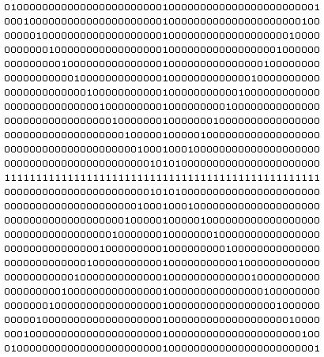
Figure 2: Example Matrix
While this picture is very cool to be able to make, it is also important to be able to save it. To do this it must be written out or outputted to a file.

Instructions
For this lab:
1.) Write a script (.m file) that creates a matrix filled with zeros or ones.
2.) Your matrix must be a minimum size of 25 x 50. There needs to be twice as many columns as rows so that the matrix appears square.
3.) Manipulate this matrix using MATLAB commands and loops to create an image or pattern in the matrix. If your initial matrix is zeroes, add ones; and if your initial matrix is ones, add zeros.
4.) Your shape cannot be a simple square or a plus sign. It must involve at least four different "lines" or pieces that create the picture.
5.) Finally, write this image out to a text (.txt) file using file open and printing commands. Remember to include both your (commented) code and the resulting text file image in your lab report.
Note: do not manipulate individual cells; the point here is to identify and use patterns to make the image.

Deliverables
- Your project report (see below)
- Your script file
- Your matrix image as a text file
Project Report
Below is the point distribution for required sections in the lab report. Be sure that each section is labeled clearly. Refer to the lab submission guidelines for details on what goes in each section.

Section | Points | Notes
1.Task Description | 1
2.Learning Objectives | 1
3.Approach | 1
4.Program Description | 1
5.Source Code | 9 | See the source code restrictions in the lab description.
6.Code Execution Results | 1 | Copy the contents of the output text file into this section.
7.Conclusions | 1
 | 15 total

Submit your results in the correct place in Blackboard Learn (http://bblearn.nau.edu) by the due date.

References
1. http://www.juxtapost.com/site/permlink/3ec9ce80-7523-11e1-aac1-4f4032d55d4a/post/mickey_mouse_ascii_art_disney/
2. http://www.dougsartgallery.com/ASCII-Art-Gallery.html

